**User Guide**

SCGJ/Safai Karamchari – App

<https://www.scgjsksd.in>

Contents

General Information: 3

System Overview: 3

Application Login: 4

Instructions 4

Admin Dashboard 5

View Documents 6

Steps to find the documents uploaded by Training Partner 6

Generate Credentials 7

Steps to follow to generate credentials for training partners 7

Steps to follow to view the generated credentials for training partners 7

Update Targets 8

Steps to follow to update targets 8

Steps to follow to search the updated targets 8

# General Information:

SCGJ/Safai Karamchari - App is a web application which will be used by Skill Council for Green Jobs and its training partners as an operational and monitoring tool to carry out training of Safai Karamchari pan India. Due to the increase in the number of candidates being trained all over the country, it becomes difficult to manage all the information manually and maintain records in the excel sheets. This tool will help the training partners to generate different reports and excel sheets through the system and send it to the skill council which was earlier done manually. This tool will reduce the redundancy that exists in the current system where the training partner used to create different excel sheets for the same candidates where he had to enter the same information several times.

## System Overview:

The application has been divided into the following parts:

* Skill Council’s View
  + Online creation of user credentials and target allocation for training partner by SCGJ via – Generate Credentials
  + Functionality to view the documents uploaded by the training partner via – View Documents
  + Real – Time monitoring of accurate data and statistics via – Dashboard
  + Functionality to update targets of Training Partners
* Training Partner’s View
  + Functionality to import data into the system via – Data Import
  + Automated Report Generation for batches via – Generate Report
  + Functionality to upload reports and documents for SCGJ via – Upload Documents
  + Personalised dashboard for training partner for monitoring purpose

# Application Login:

The login screen of the application will provide the role-based logins for both the Admins and the Training Partners

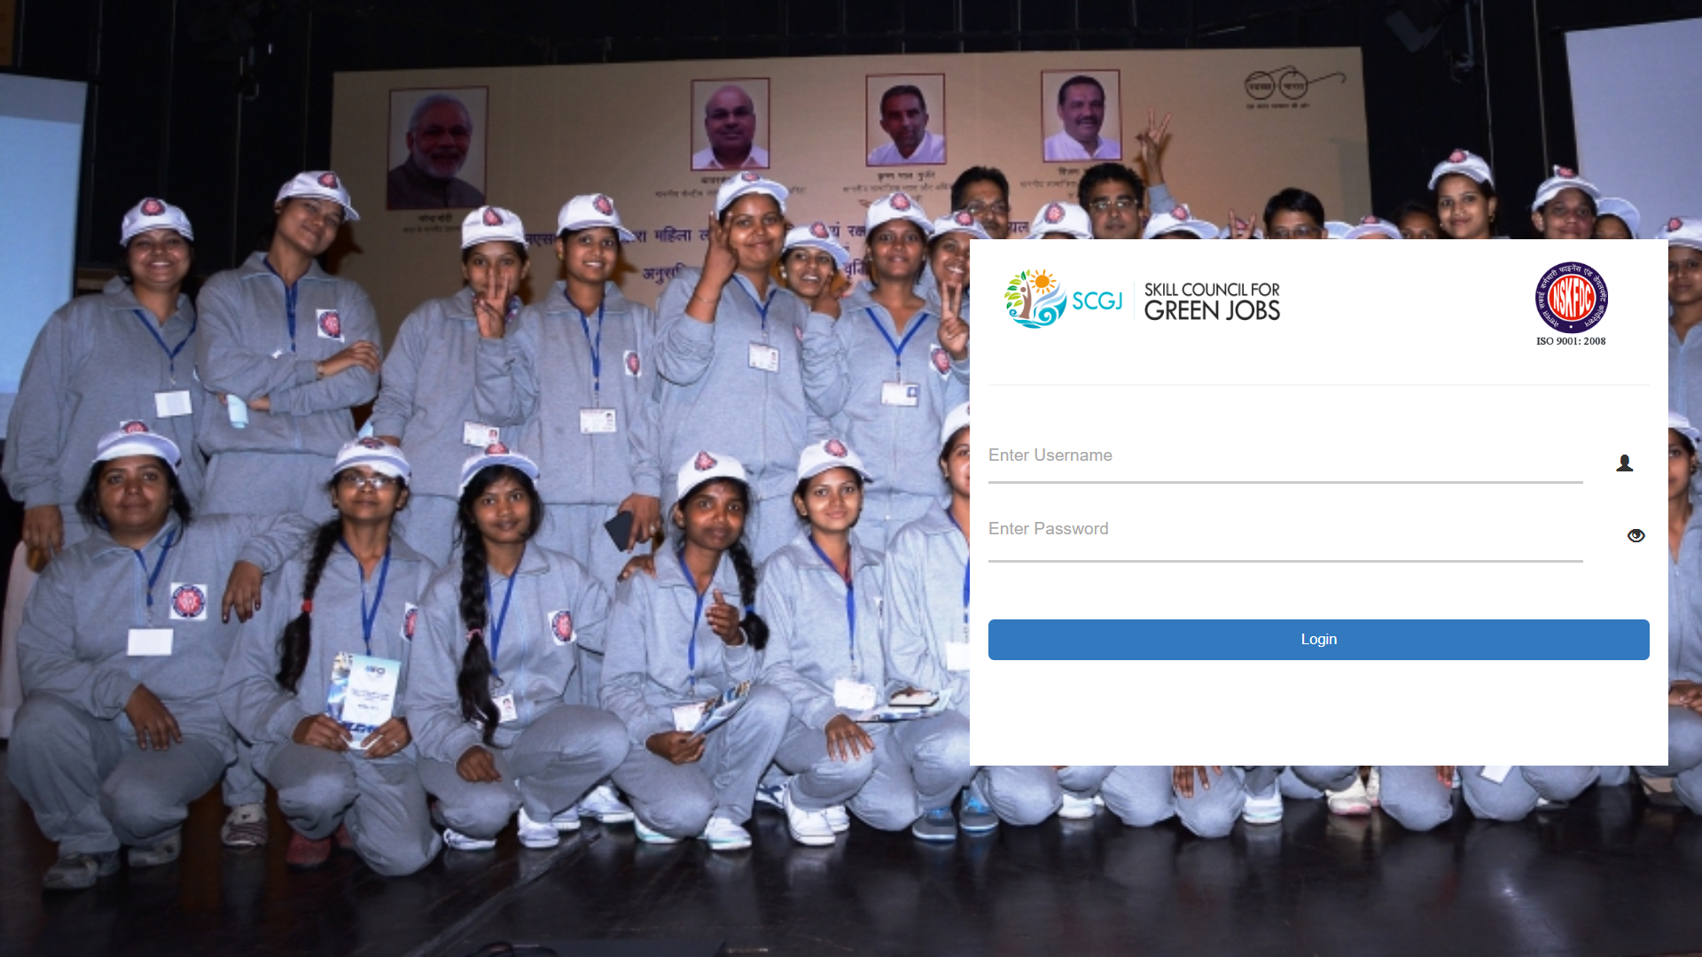

### Instructions

To login to the application please follow the given steps:

* Enter the link on the web browser as <https://www.scgjsksd.in> and click enter
* A login screen as shown in the figure will appear on the screen
* Enter the Email ID and Password
* You can also click on the eye icon (Password Visibility) to check the password
* After entering the details click on the **login** button
* After clicking on the login button if you are an authentic user then you would be directed to your respective screens

# Admin Dashboard

Dashboard of SSDMS is the part of the application where most important data would be available in the form of statistics and infographics. This module will contain information such as:

* Ongoing Training(s)
* Candidates Trained
* Training Partners
* Upcoming Assessments

The information is also available in the form of infographics which includes

* Top 5 states having maximum training centres
* Candidates trained in last 6 months
* Training Centers in each State

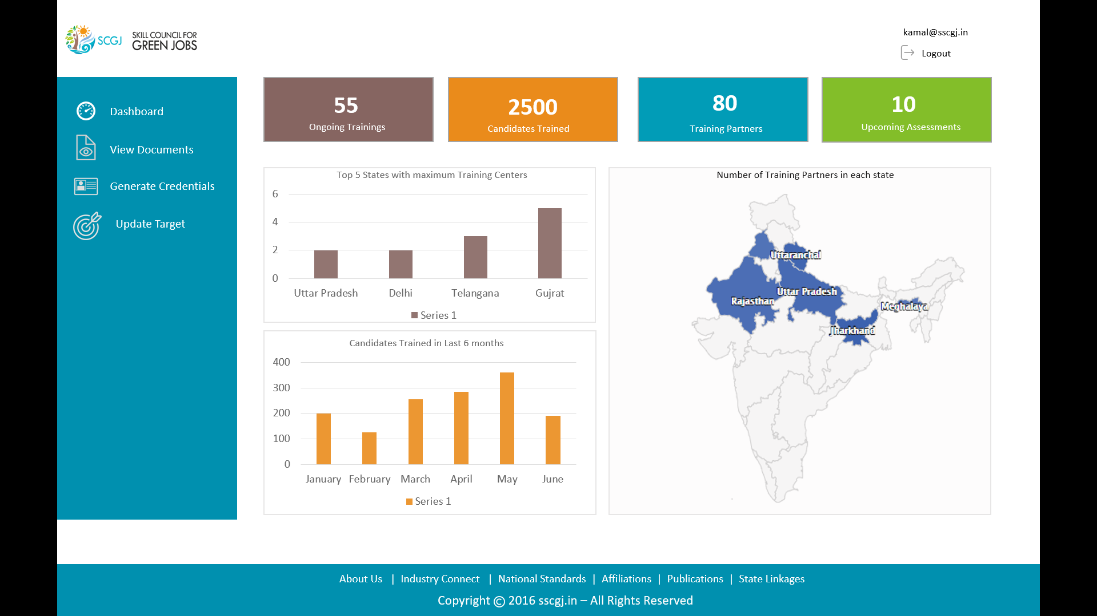

# View Documents

View Documents functionality will be used by the SCGJ Admin to view the documents that have been uploaded by the training partners.

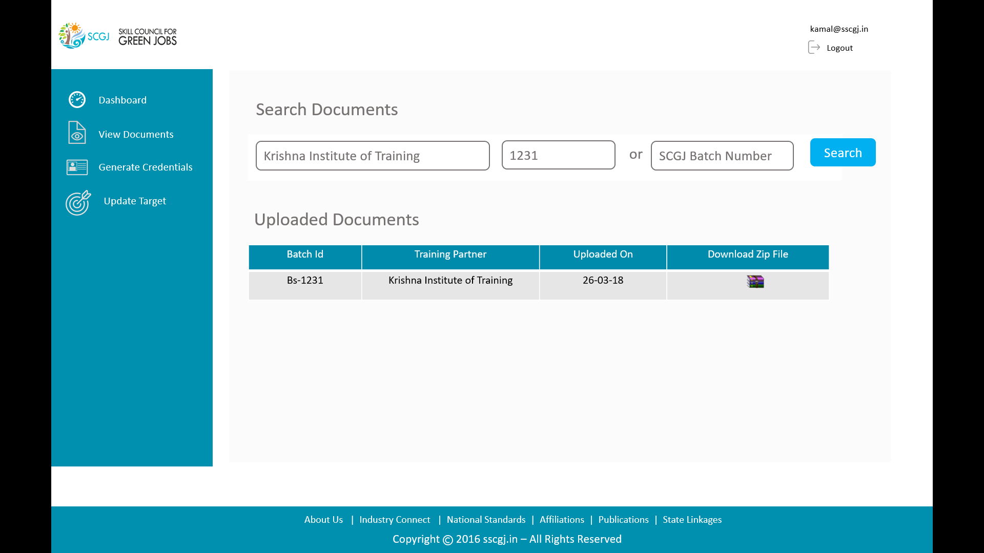

### Steps to find the documents uploaded by Training Partner

Please follow the following steps to find the documents uploaded by the training partner:

* Navigate to the View Documents page
* In the search documents section, Enter the name of the Training Partner
* Enter the Batch Id or the SCGJ batch Number for which the documents are needed
* Click on the Search Button
* The table under the Uploaded Documents section will be populated with the result if the training partner has uploaded documents for that batch ID
* Click on the zip icon to download the zip
* A zip file will be downloaded which will contain all the documents that have been uploaded by the training partner

# Generate Credentials

The Generate Credentials functionality will allow the SCGJ Admin to generate Credentials for the Training Partners

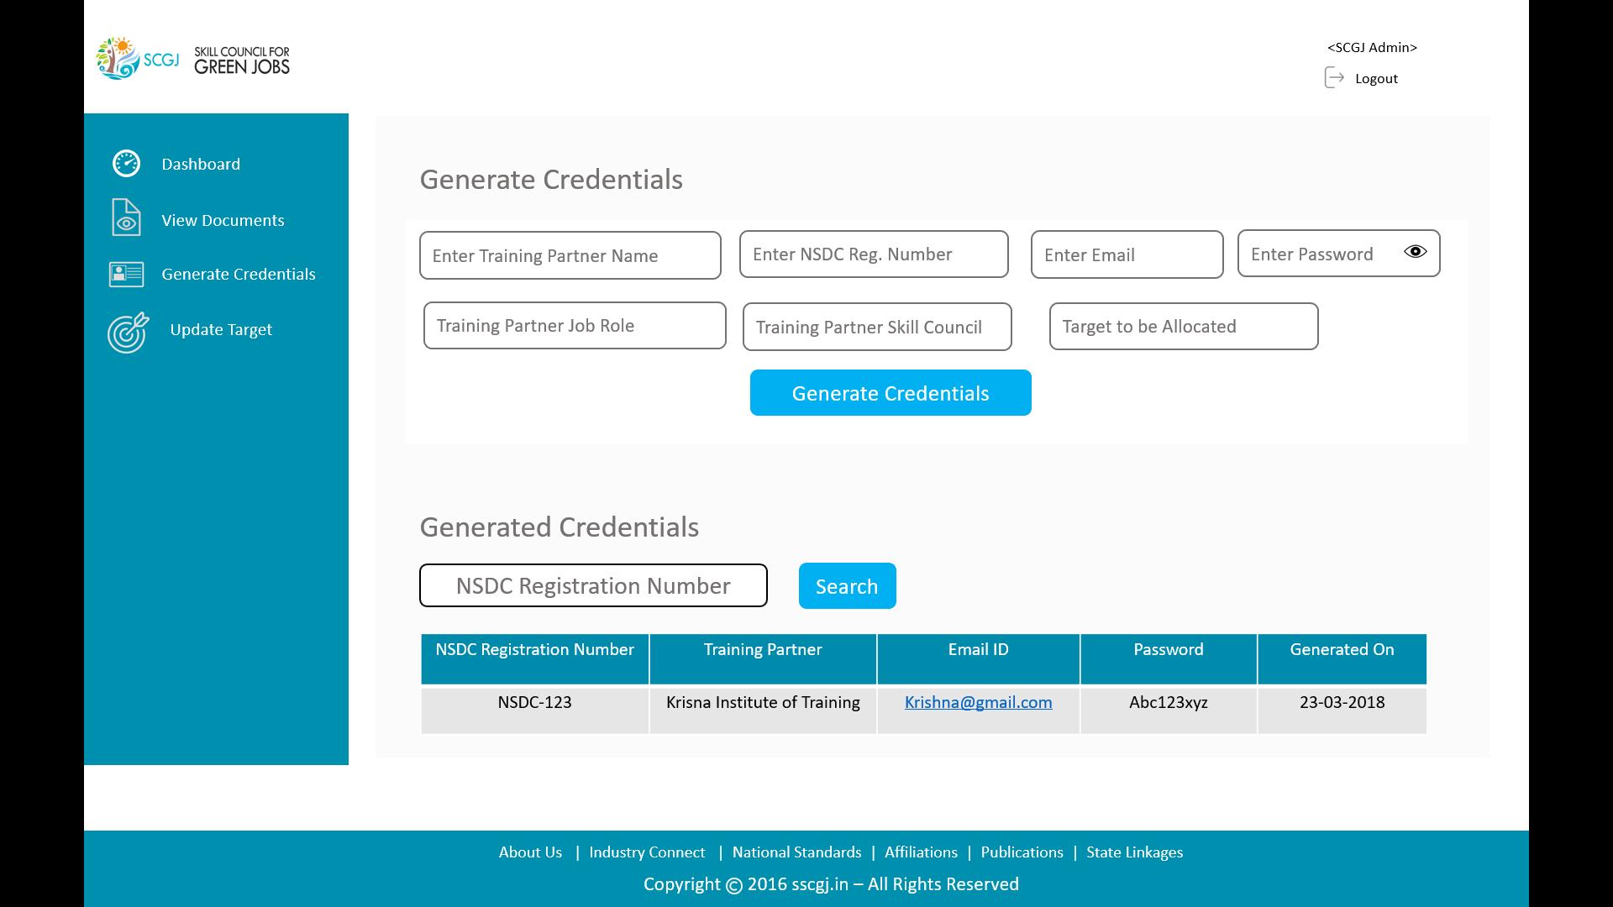

### Steps to follow to generate credentials for training partners

Please follow the given instructions to generate credentials for training partners:

* Navigate to generate credentials section by clicking on generate credentials tab on left navigation
* Under the Generate Credentials section enter the information given in text box
* Enter the target which is to be allocated to the training partner for the current financial year
* Click on the generate credentials button, A success message saying “User Credentials Generated Successfully” will be shown if the user is new in the system and if the user already exists then an error message saying “User Already Exists” will be populated

### Steps to follow to view the generated credentials for training partners

Please follow the given instructions to view the generated credentials for training partners

* Under the Generated Credentials section, Enter the NSDC Registration Number
* After entering the NSDC Registration Number and click on the Search Button
* The details of the credentials generated for the training partner will be displayed in the below table

# Update Targets

The Update Targets functionality will be used by the SCGJ Admin to update the targets of the training partner for the current financial year by entering the NSDC Registration Number and the Targets

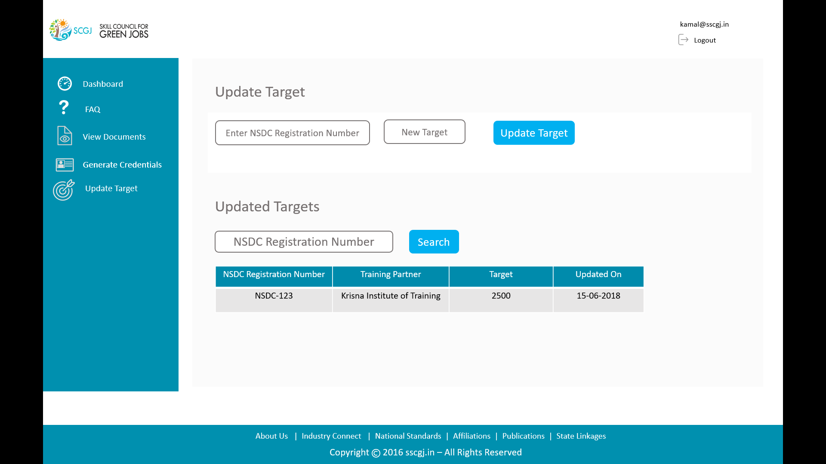

### Steps to follow to update targets

Please follow the given steps to update the targets of Training Partners:

* Navigate to the Update Targets tab by clicking on the update targets tab from the left navigation
* Under the Update Target section, Enter the NSDC Registration Number and New Target for this financial year
* After entering the new target click on the Update Target Button
* If the targets are updated a success message saying, “Targets updated successfully!” will be populated and if the NSDC Registration Number of the Training Partner does not exists in the system then an error message saying “Training Partner with NSDC Reg. Number does not exists” will be populated

### Steps to follow to search the updated targets

Please follow the given steps to search for the updated targets:

* Under the Updated Targets Section, Enter the NSDC Registration Number and click on Search Button
* The result of the updated targets will be populated in the table